The top-down Finite Time Pharmacokinetic (FTPK) models vis-a-vis the bottom-up PBPK models in early drug development
Panos Macheras^{1,2*}, Nikos Alimpertis¹, Athanasios A. Tsekouras³
¹Faculty of Pharmacy, Laboratory of Biopharmaceutics Pharmacokinetics, National and Kapodistrian University of Athens, Athens, Greece
²Finite Absorption Time (F.A.T.) Laboratories, National and Kapodistrian University of Athens, Athens, Greece
³Department of Chemistry, Laboratory of Physical Chemistry, National and Kapodistrian University of Athens, Athens, Greece
*Correspondence, macheras@pharm.uoa.gr
Supplementary material
Data presented in Fig. 2 are analyzed with the classical one-compartment model with first order absorption kinetics lasting for infinite time. In the cases of nefazodone and furosemide the absorption and elimination rate constants were found almost equal, highly correlated, and with high uncertainties. Consequently, the analysis was repeated with a common rate constant. Listed values for the Akaike Information Criterion (AIC) are higher than those determined for the fits of the FTPK models, which can be found in Fig. 2.
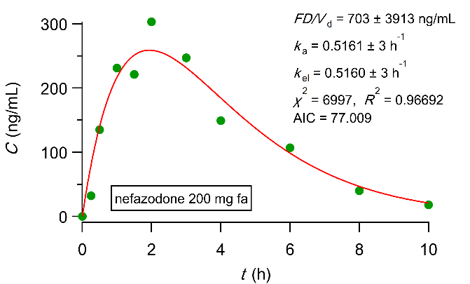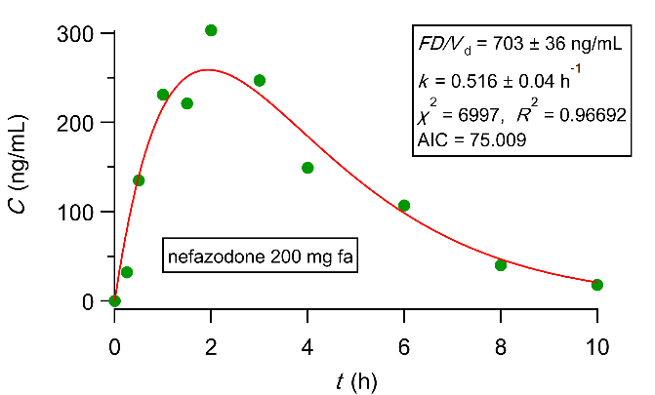
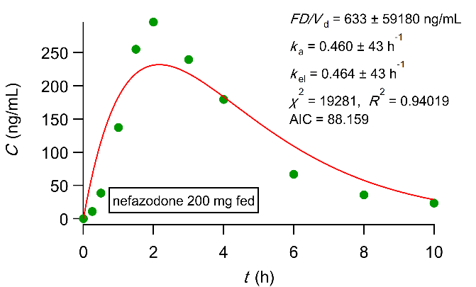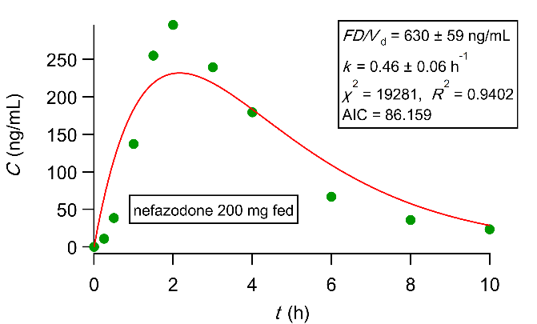
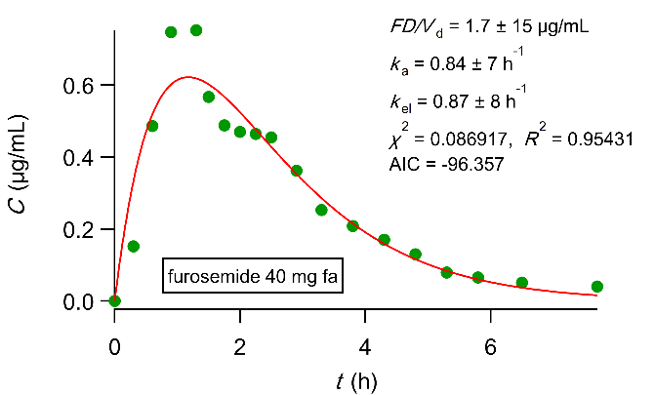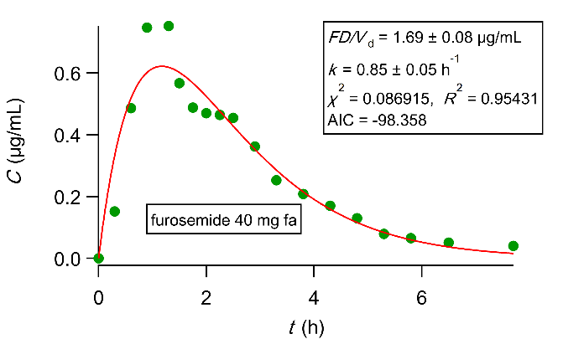
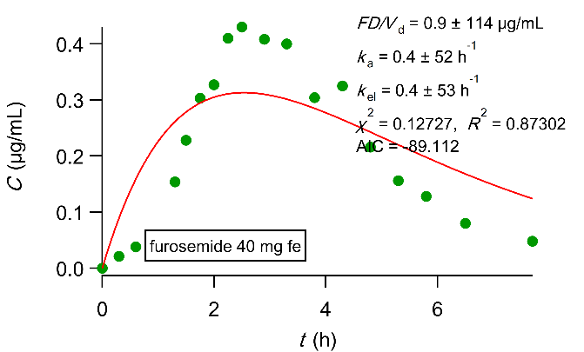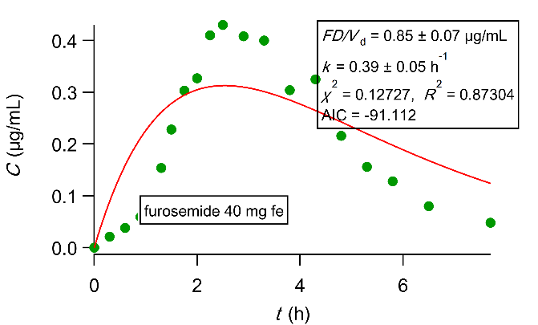
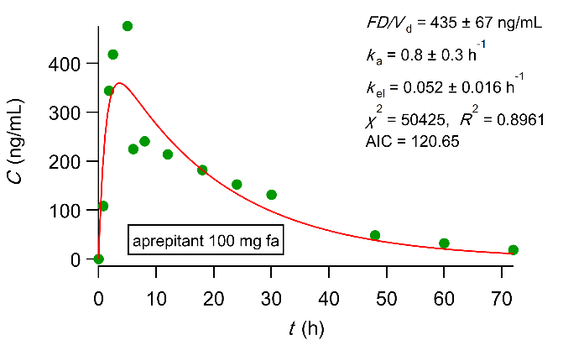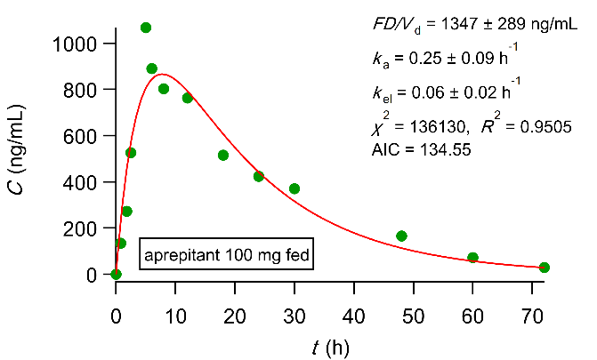
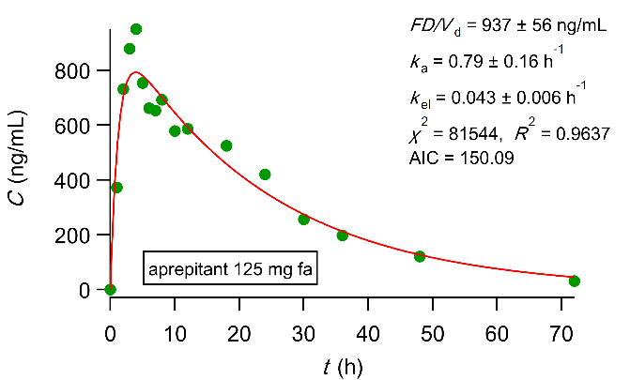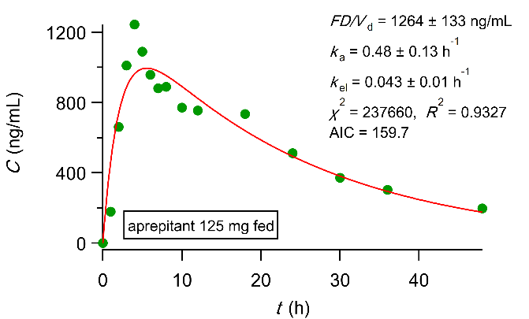
Fig. S1 Fittings with classical model for data presented in Fig. 2.

